Tutorial link: <http://igorzelmanovich.blogspot.in/2012/03/setting-up-git-git-extensions-and.html>

<http://www.tikalk.com/net/setting-git-git-extensions-and-github-account>

GitHub Extension (.exe)Download link :<http://goo.gl/PHbqK> or <http://msysgit.github.io/>

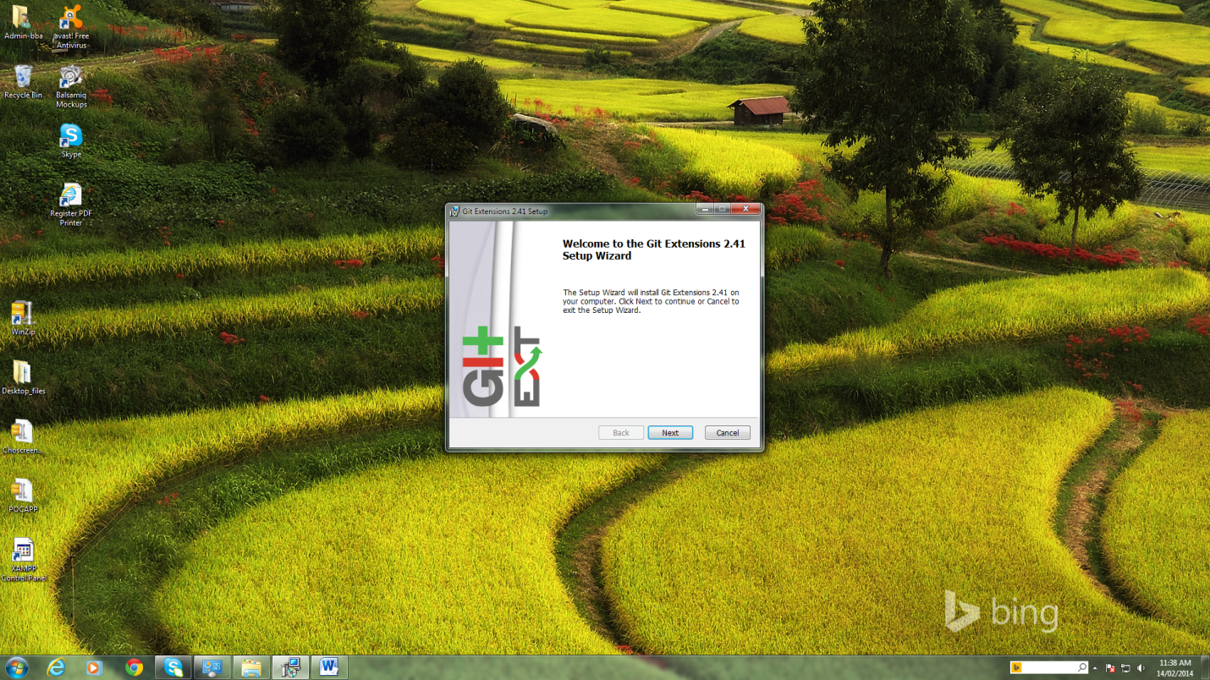

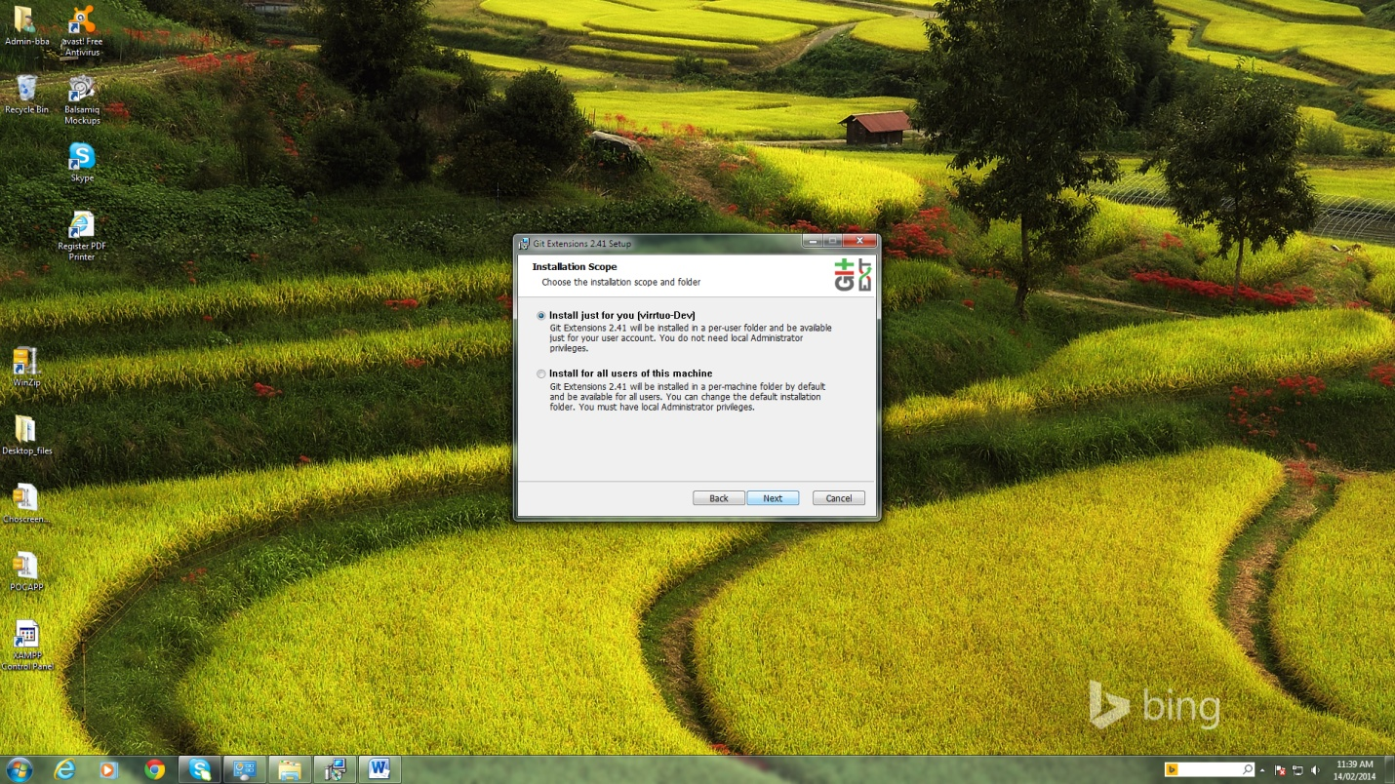

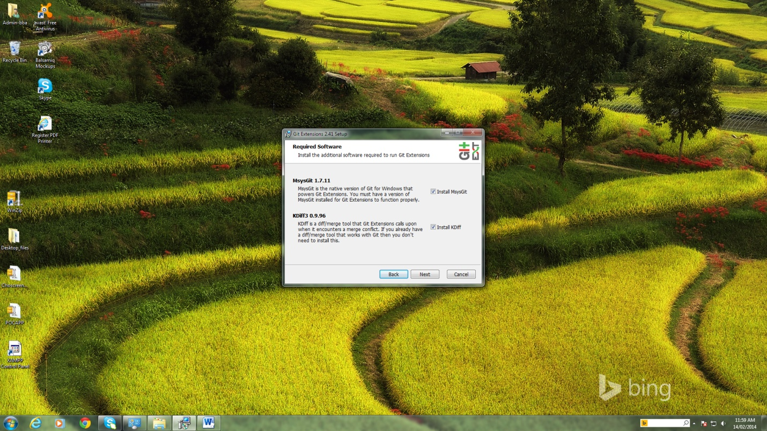

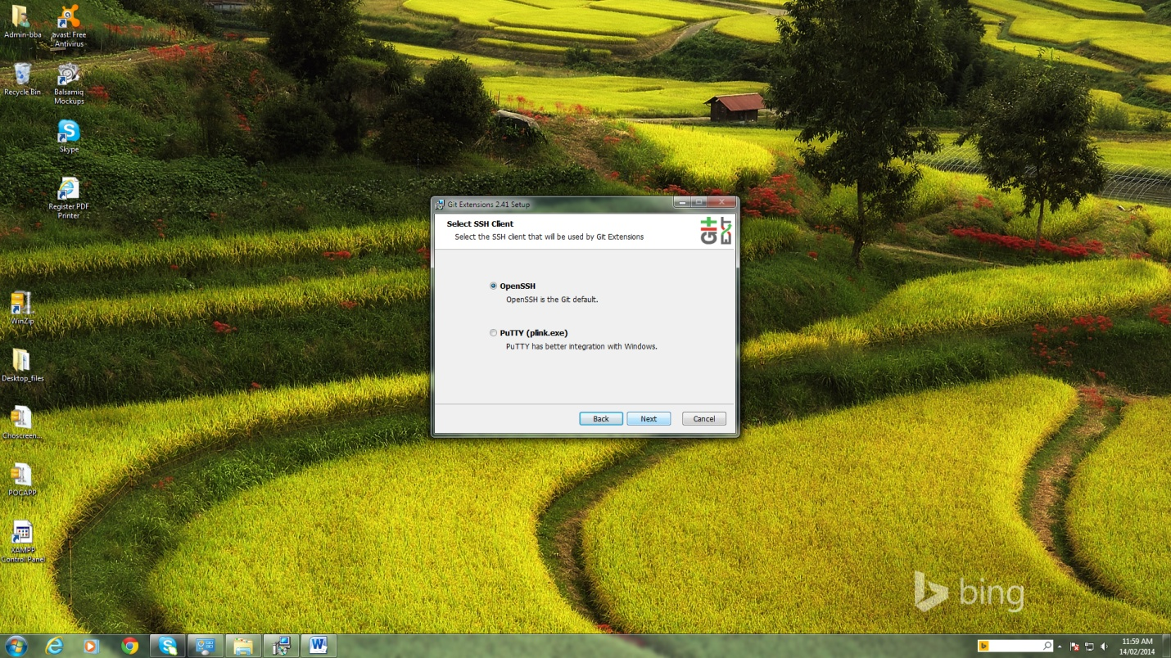

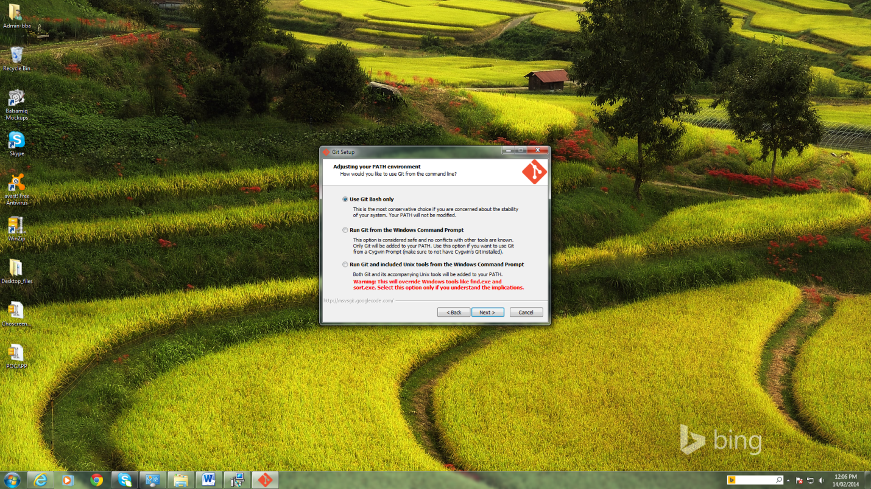

After this screen KDiff3 and GitBash will install.OnceGithub installation is completed below screen will open. (Very first time ).

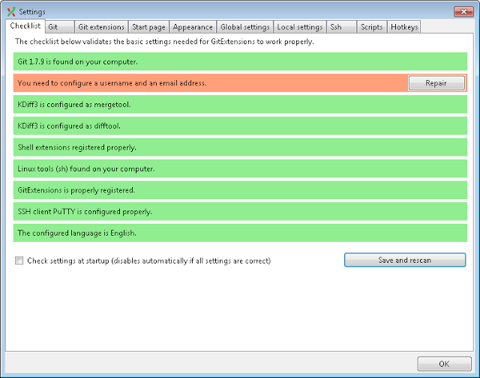

If we press Repair button below screen will open.

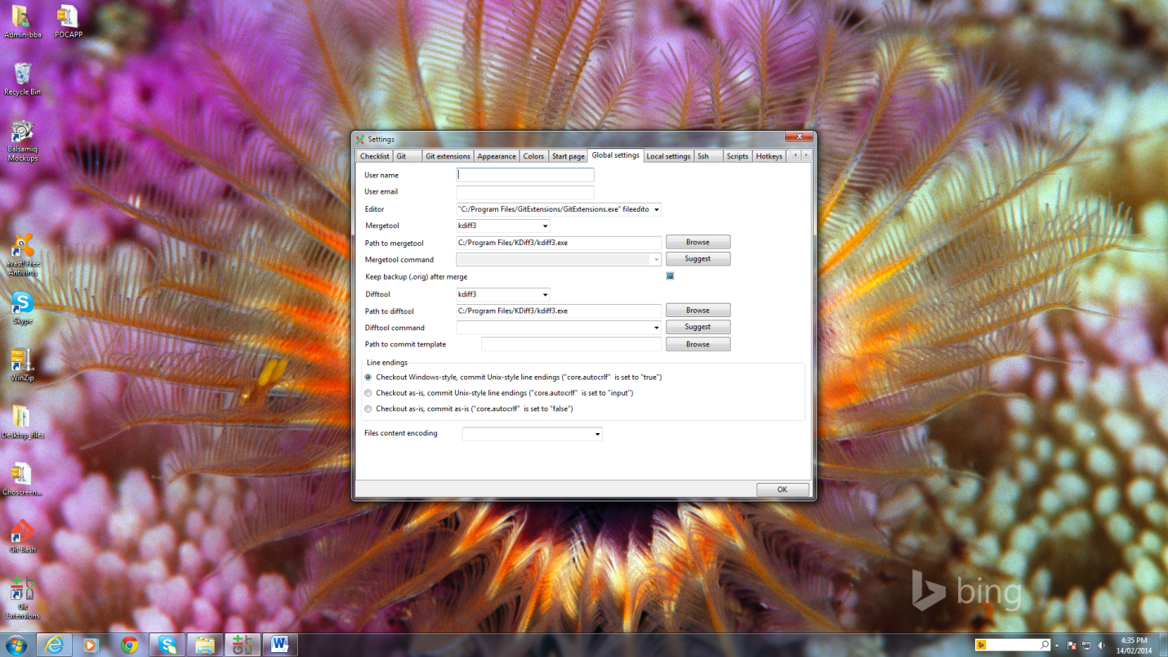

In this screen we have to fill all information i.e.username and email id (GitHub)

Note:Before giving username and user email we should create account for us (<https://github.com/>)

# How to create sshkey:

https://help.github.com/articles/generating-ssh-keys

Step 1: open GitBash screen

Step 2:Type the command ssh-keygen -t rsa –C “[youremail@gmail.com](mailto:youremail@gmail.com) “ .Now key has been generated in default location. If you are Windows7 user, it will be like below:

Ie. C:\Users\Nanjundan\.ssh

Step 3.Add your SSH Key to GitHub (Copy id_rsa file) account.

* Go to Account Settings
* Click “[**SSH Keys"**](https://github.com/settings/ssh)**in the** left sidebar
* Click Add SSH Key
* Click "Add key"
* Confirm the action by entering your GitHub password

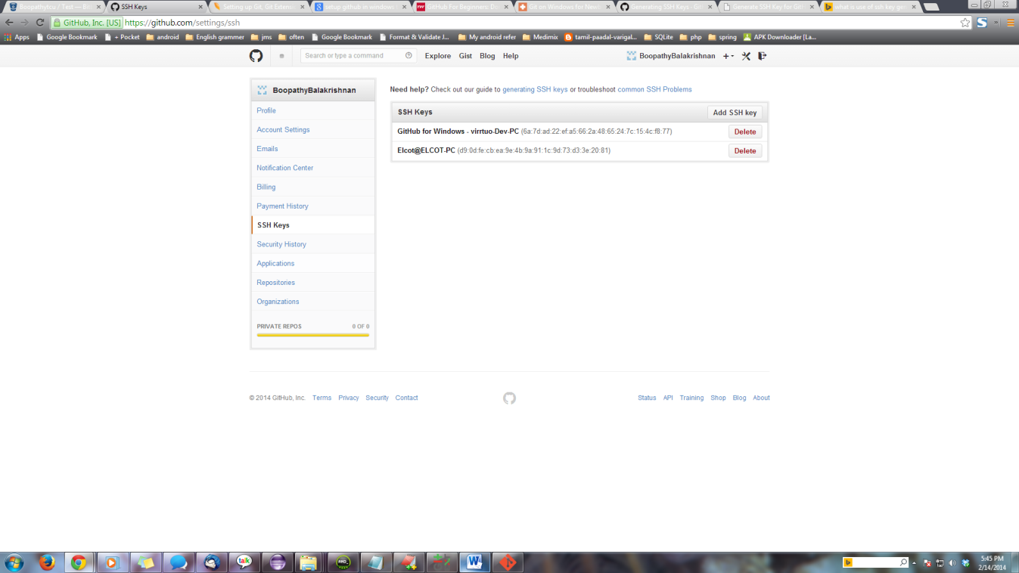

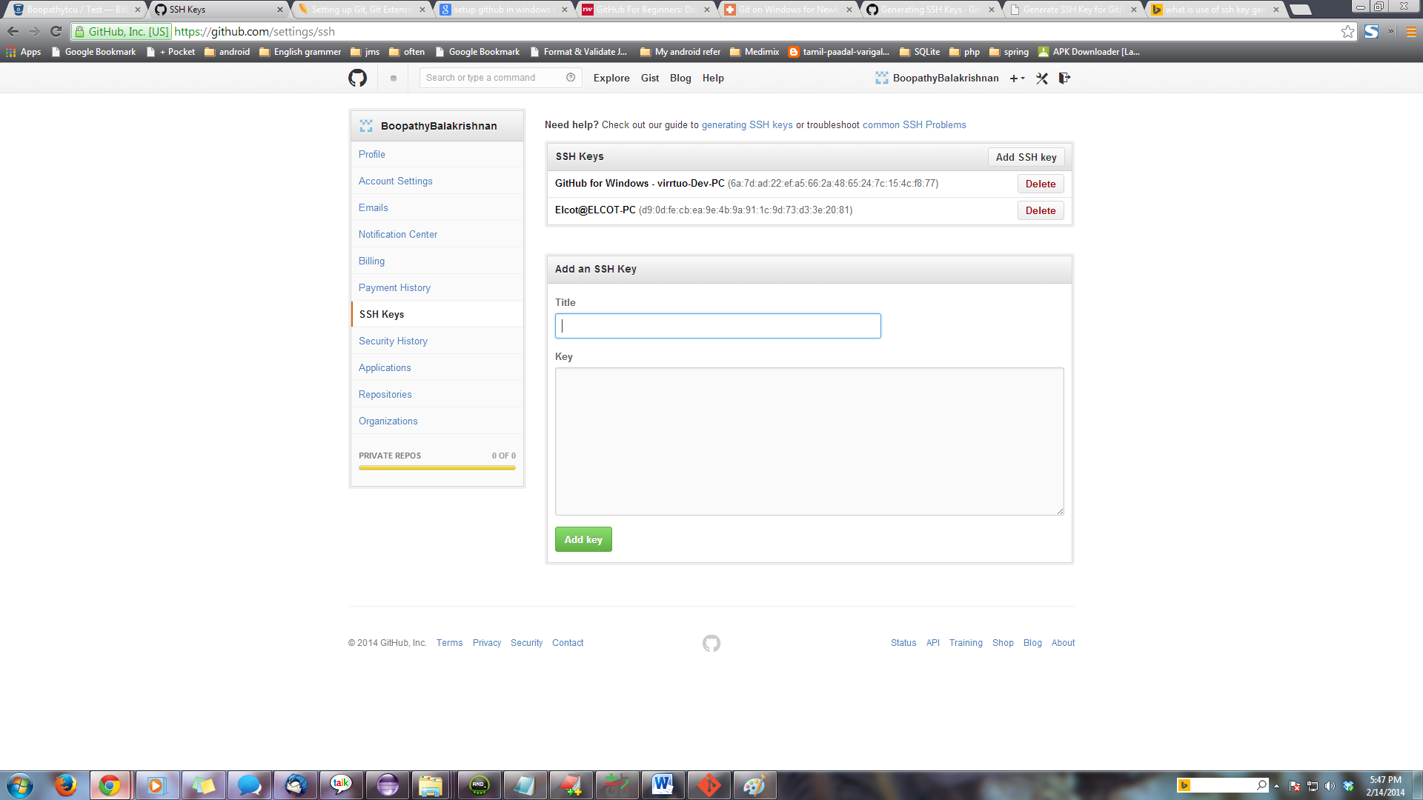

**Open GitExt click clone Repository**

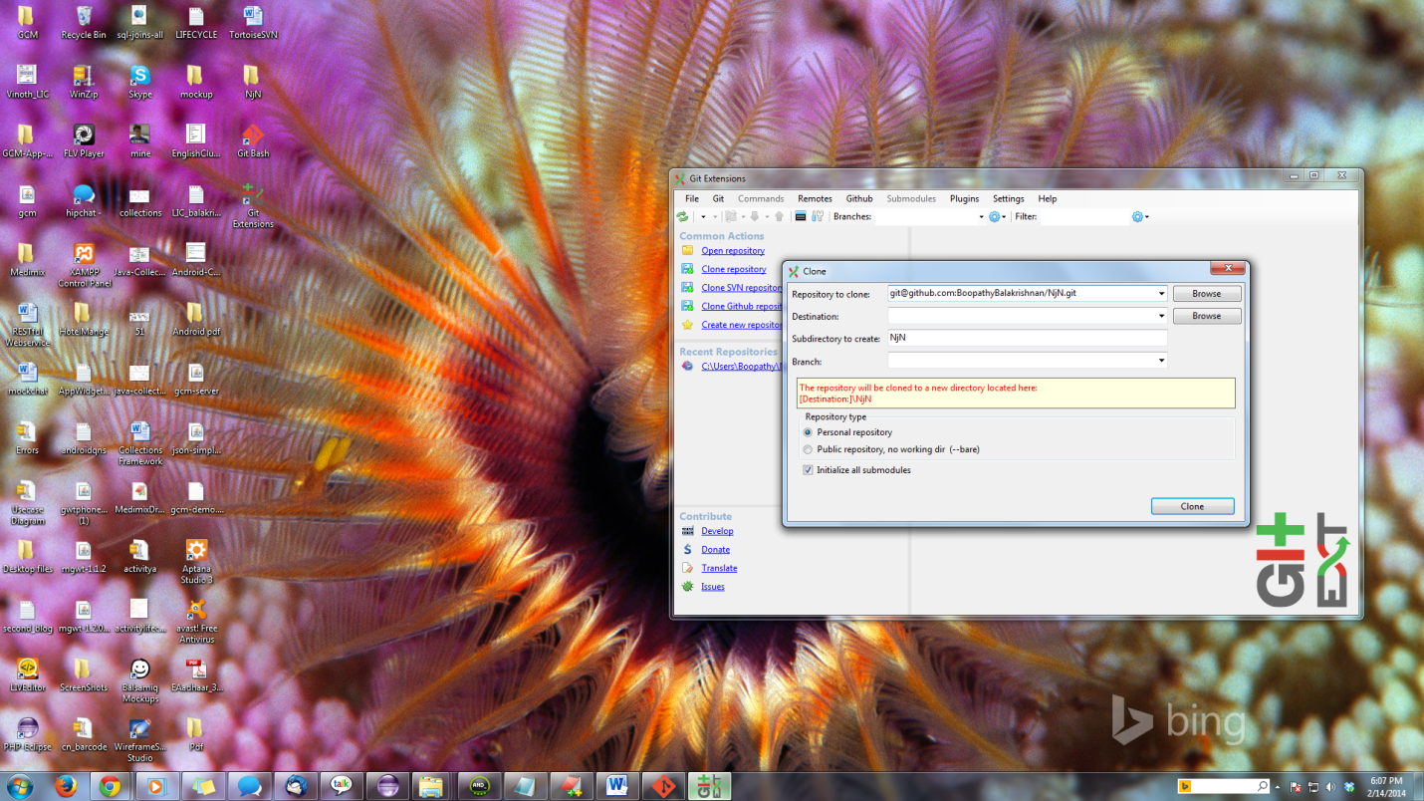

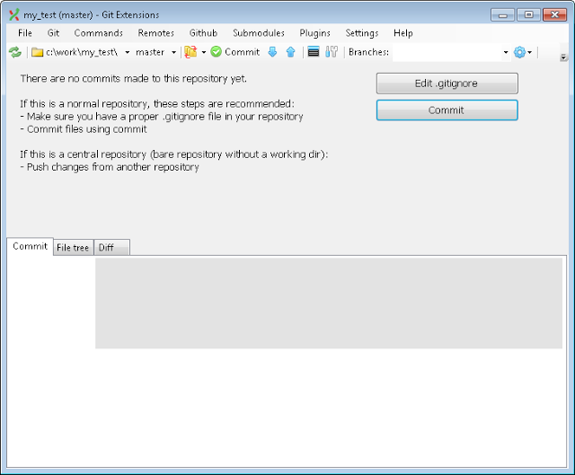

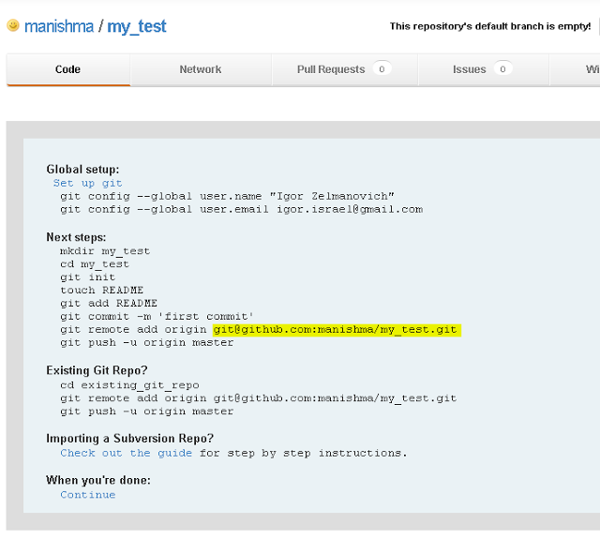

//reference

http://code.tutsplus.com/articles/team-collaboration-with-github--net-29876

Create Teams and Members:

1. **Adding Team Members** - Organization & Collaborators
2. **Pull Requests** - Sending & Merging
3. **Bug Tracking** - Github Issues
4. **Analytics** - Graphs & Network
5. **Project Management** - [Trello](https://trello.com/) & [Pivotal Tracker](https://www.pivotaltracker.com/)
6. **Continuous Integration** - [Travis CI](https://travis-ci.org/)
7. **Code Review** - Line Commenting & URL queries
8. **Documenting** - Wiki & [Hubot](http://hubot.github.com/)

## Tool 1: Adding Team Members

There are generally two ways of setting up Github for team collaboration:

1. **Organizations** - Organization owner can create many teams with differing permission levels for various repositories
2. **Collaborators** - Repository owner can add collaborators with Read + Write access for a single repository

### Organizations

If you are supervising several teams and would like to set different permission levels for each team with various members and add each member to different repositories, then Organization would be the best option. Any Github user account can already create free Organizations for open source code repositories. To create an Organization, simply browse to [your organization's settings page](https://github.com/settings/organizations):

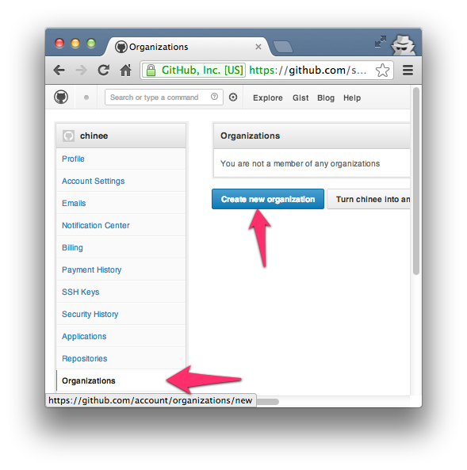

To access the teams page for your Organization, you can simply go tohttp://github.com/organizations/[organization-name]/teams to view them or even visit https://github.com/organizations/[organization-name]/teams/new to create new teams with members of 3 different permission levels such as:

1. **Pull Only:**[Fetch and Merge](http://www.kernel.org/pub/software/scm/git/docs/git-pull.html) with another repository or a local copy. Read only access.
2. **Push and Pull:**(1) along with [updating](http://www.kernel.org/pub/software/scm/git/docs/git-push.html) of remote repo. Read + Write access.
3. **Push, Pull & Administrative:**(1), (2) along with rights to billing info, creating teams as well as canceling Organization accounts. Read + Write + Admin access

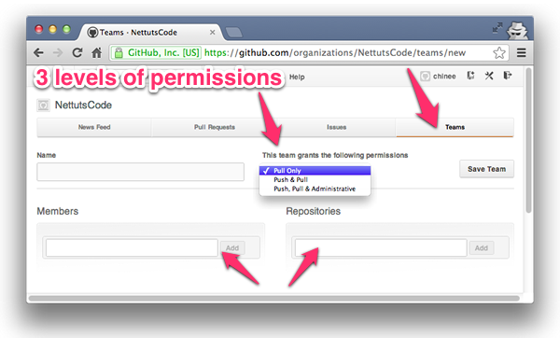

### Collaborators

Collaborators are used to give both **Read + Write access** to a single repository owned by a personal account. To [add Collaborators](https://help.github.com/articles/how-do-i-add-a-collaborator), (other Github personal accounts) just go to https://github.com/[username]/[repo-name]/settings/collaboration:

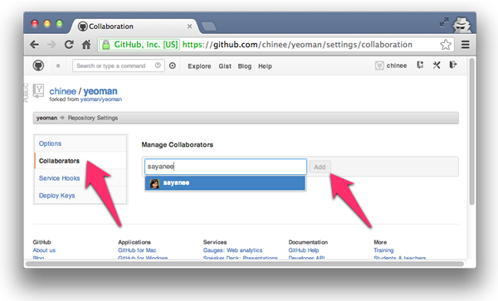

Once that is done, each Collaborator will then see a change in the access status on the repository page. After we have Write access to the repository, we can do a git clone, work on the changes, make a git pull to fetch and merge any changes in the remote repository and ultimately git push, to update the remote repository with our own changes:

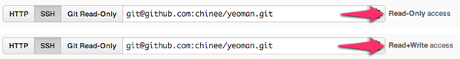

## Tool 2: Pull Requests

[Pull Requests](https://help.github.com/articles/using-pull-requests) are an awesome way to contribute to a repository independently by forking it. At the end of the day, if we wish, we can send a pull request to the repository owner to merge our code changes. The pull request in itself can then fire off discussions for code quality, features or even general strategy.

Let's now go through the basic steps for a [pull request](https://help.github.com/articles/using-pull-requests).

### Initiating a Pull Request

There are [two models of pull request](https://help.github.com/articles/using-pull-requests) in Github:

1. **Fork & Pull Model** - Used in a public repository for which we don't have push access
2. **Share Repository Model** - Used in a private repository for which we have push access. Fork is not required is this case.

Here we see the workflow between two users (repo-owner and forked-repo-owner) for the Fork and Pull model:

1. Identify the Github Repository that you want to contribute to, and click the "Fork" button to create a clone of the repository in your own Github account:



1. This will create an exact copy of the repository in your own account

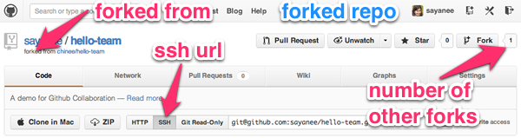

1. [Choose the SSH URL](https://help.github.com/articles/why-is-git-always-asking-for-my-password) so that it will ask for your SSH key passphrase instead of the username and password each time you git push or git pull. Next, we will clone this repository to our local machine:

$ git clone [ssh-url] [folder-name]

$ cd [folder-name]

1. Generally, we will create a new git branch for each new feature. This is a good practice because in the future if we further update the branch after some discussions, the [pull request will be automatically updated](http://stackoverflow.com/questions/9790448/how-to-update-a-pull-request). Let's create a new branch to make a very simple change to amend the readme.md file:

$ git checkout -b [new-feature]

1. After making the relevant additions to build the new features, we will just commit the new changes and checkout to the git master branch:

$ git add .

$ git commit -m "information added in readme"

$ git checkout master

1. At this point, we will push the branch to the remote repository. For this we will first check the branch name with the new feature as well as the git remote repository aliases. Then we will push the changes using git push [git-remote-alias] [branch-name]:

$ git branch

* master

readme

$ git remote -v

origin  git@github.com:[forked-repo-owner-username]/[repo-name].git (fetch)

origin  git@github.com:[forked-repo-owner-username]/[repo-name].git (push)

$ git push origin readme

1. In our forked repository Github page, we will change to the branch with the new feature and then hit the "Pull Request" button.

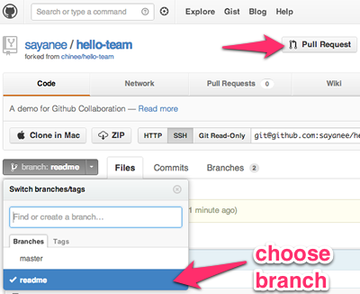

1. After submitting the pull request, it will directly take us to the original repository's pull request page. We will see our pull request, both as a new issue as well as a new pull request.

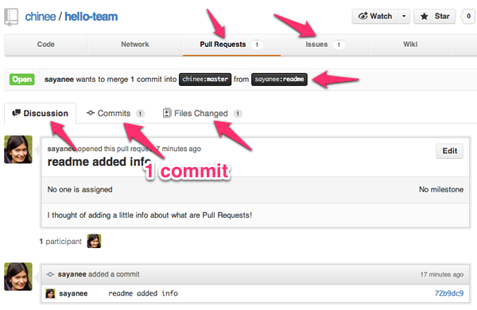

1. After the discussion, it might be possible that the forked repository's owner might want to add changes to the new feature. In this case, we will checkout to the same branch in our local machine, commit it, and push it back to Github. When we visit the pull request page of the original repository, it will be automatically updated!
2. 